Area: All facilities | Date of issue: April 1, 2024 | Approved by:
Title: Summary of Procurement Policy | Last date of review:

Policy

The purpose of this policy is to ensure that publicly funded goods and services, including construction, consulting services, and information technology are acquired by Family & Children’s Services of the Waterloo Region (FACS) through a process that is open, fair, and transparent.

The Policy is based on the following five key principles:
- Accountability: FACS must be accountable for the results of their procurement decisions and the appropriateness of the processes.
- Transparency: FACS must be transparent to all vendors. Wherever possible, vendors must have equal access to information on procurement opportunities, processes, and results.
- Value for Money: FACS must maximize the value they receive from the use of public funds. A value-for-money approach aims to deliver goods and services at the optimum total lifecycle cost.
- Quality Service Delivery: Front-line services provided by FACS, such as teaching and patient care, must receive the right product, at the right time, in the right place.
- Process Standardization: Standardized processes remove inefficiencies and create a level playing field.

Code of Ethics

The Ontario Broader Public Sector Supply Chain Code of Ethics must be formally adopted in accordance with governance processes. FACS will ensure that the Code is available and visible to all members of the organization and to suppliers and stakeholders involved with the Supply Chain process.

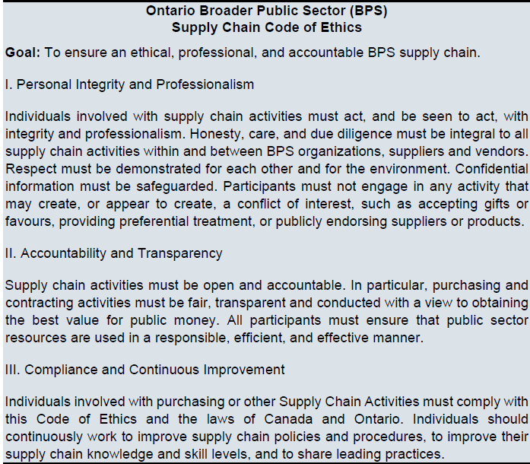

See next page for the Competitive Procurement Thresholds and Approval Authority.

Competitive Procurement Thresholds
Goods, Non-Consulting Services and Construction
Total Procurement Value | Means of Procurement | Recommended/Required
$0 up to $99.99 | Petty cash | Recommended
$100 up to $2,999.99 | Credit card | Recommended
$3,000 up to $9,999.99 | Purchase order (Template is on last page of this document) | Recommended
$10,000 up to $121,199.99 | Invitational competitive procurement (minimum of three suppliers are invited to submit a bid) | Recommended
$121,200 or more | Open competitive process | Required
Consulting Services
Total Procurement Value | Means of Procurement | Recommended/Required
$0 up to but not including $121,200 | Invitational or open competitive process | Required
$121,200 or more | Open competitive process | Required

Employees must not reduce the overall value of procurement (e.g., dividing a single procurement into multiple procurements to avoid the approval requirements of the organization's approval authority.

Approval Authority
Procurement Roles | Agency Position | Documentation
Budgeting | Finance Director | Agency budget as approved by Board of Directors and assigned cost centre budgets
Requisition | Office Operations (e.g. office supplies) Finance Supervisor  Building Operations (e.g. janitorial supplies and maintenance)  Facilities Services Supervisor  Technical services (e.g. IT)  Technology Services Director  Client Needs –Case worker based on budget and commitment approved by supervisor, director or director per delegation of financial authority | Documentation per procurement thresholds
Commitment | Director per delegation of financial authority | A signed contract, purchased order, or document noting commitment made
Receipt | Office Operations –receptionist at each office location  Building Operations – Facilities coordinator or Facilities Services Supervisor  Technical services - Technology Services Director  Client Needs –client in care and confirmed by case worker | Includes packing slip or other document that includes the pertinent procured information that is signed by the person who can confirm what has been received.
Payment | Accounts Payable –Finance staff based on match of authorization with confirmation of receipt, purchase order and invoice. | Invoice authorized for payment per the delegation of financial authority and matched to purchase order and receipt

Building Ontario Businesses Initiative (BOBI)

Building Ontario Businesses Initiative (BOBI) is to leverage Ontario’s purchasing power to support economic growth, and to provide the criteria for when Broader public service organizations are required to procure from Ontario or Canadian businesses. All purchases under $121,200 must give preference to Ontario suppliers.
FACS must obtain goods and services from Ontario businesses wherever possible and request each vendor demonstrate they meet the following requirements:
- has its headquarters or main office in Ontario, OR
- has at least 250 full-time employees in Ontario at the time of the applicable procurement process

FACS must use existing Vendor of Record arrangements whenever possible and appropriate, regardless of the value of the procurement. Click on link for list:
VOR Search (gov.on.ca)

Any new contract, including any extensions, must not exceed two years. In limited and exceptional circumstances, FACS may find that it is not possible or appropriate to:
- Use a VOR arrangement that is available to the organization; and/or
- Restrict contract duration to two years
In these situations, inform the Finance supervisor as they must complete a Procurement Rationale Report and submit it to the funding ministry at least 45 calendar days before the procurement is released to the vendor community.
Note that submission of the form does not change the authority of the organization to proceed with the procurement. For clarity, once the report is submitted, the organization can proceed with the procurement.
Procurement Rationale Report Form - Forms - Central Forms Repository (CFR) (gov.on.ca)

Exemptions:

The following goods and services are not prescribed for the purposes of this policy (the Act):
- A good or service required for an emergency.
- A good or service procured pursuant to a standing offer, vendor of record arrangement or a multi-use list.
- A good or service procured for commercial sale or resale or for use in the production of a good or service intended for commercial sale or resale.
- The services of a lawyer, paralegal or notary public.
- The services of an expert witness to be used in a court or legal proceeding.
- A good or service that is not available from an Ontario business.

Complete Procurement policy can be found within the Finance Policy

